***Educage user guide***

***System assembling-***

1. Connect the PCB to the behavioral chamber via serial cable into J1 connector on the PCB. Use the following connection scheme.

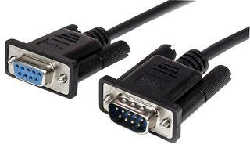

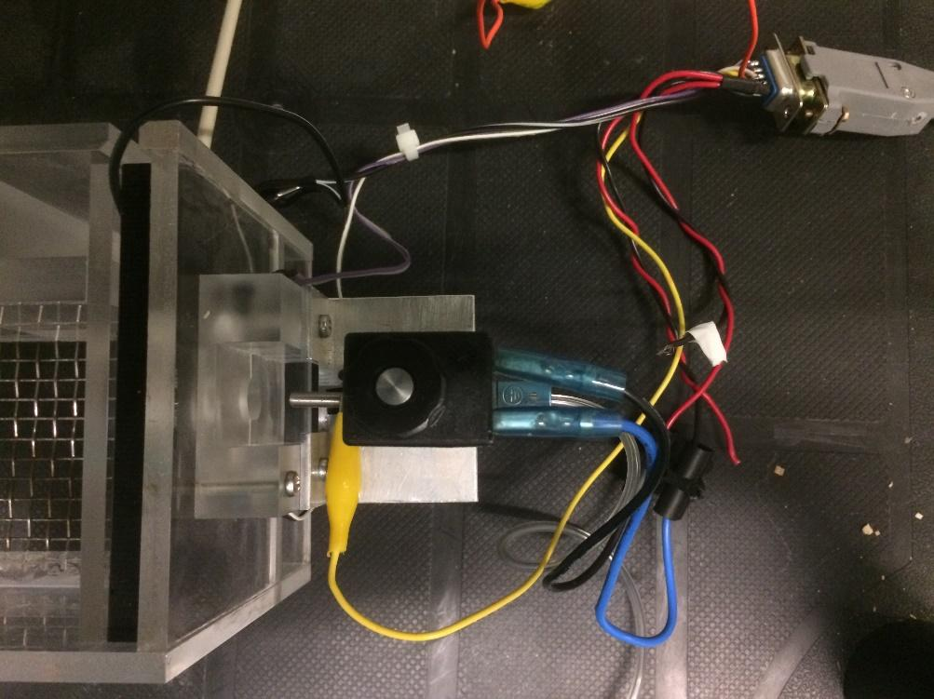

1. Connect the PCB to myRIO DIO ports via serial cable into J1 connector on the PCB. Use the following wiring map for connector C:

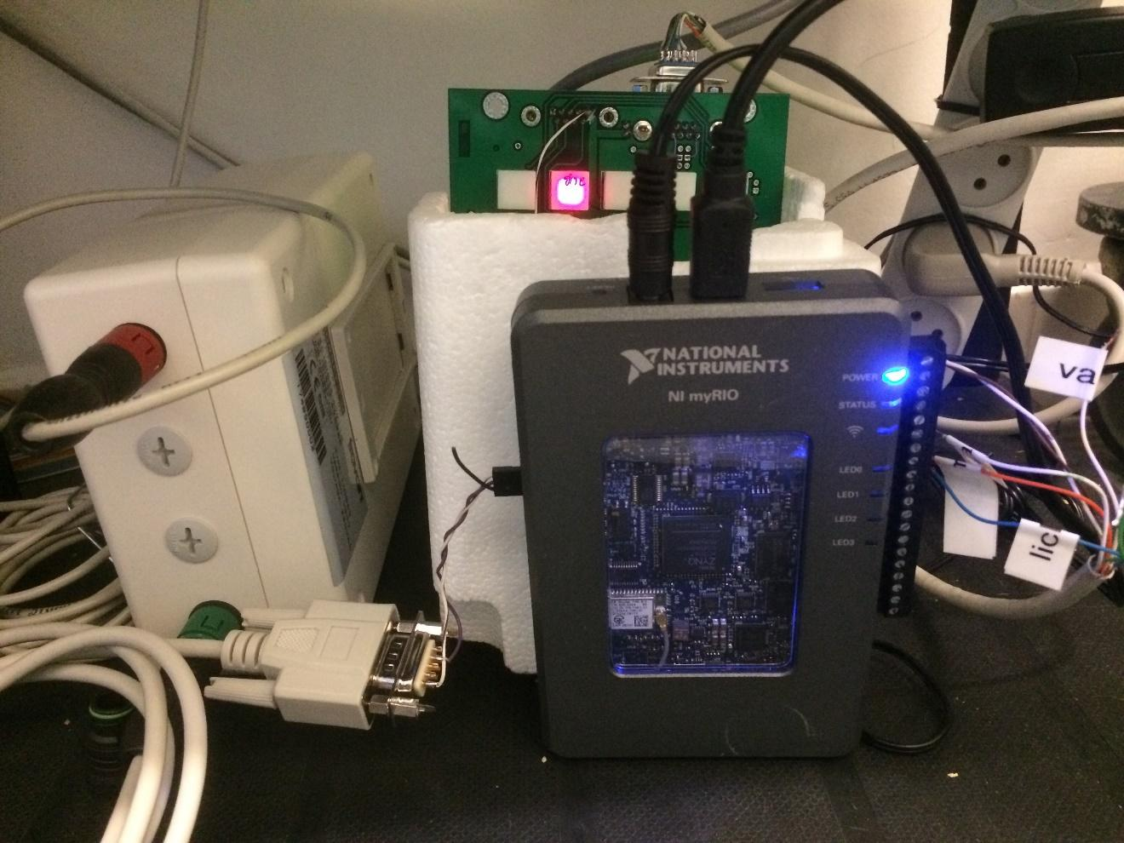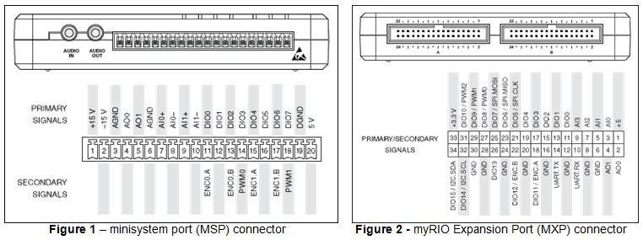

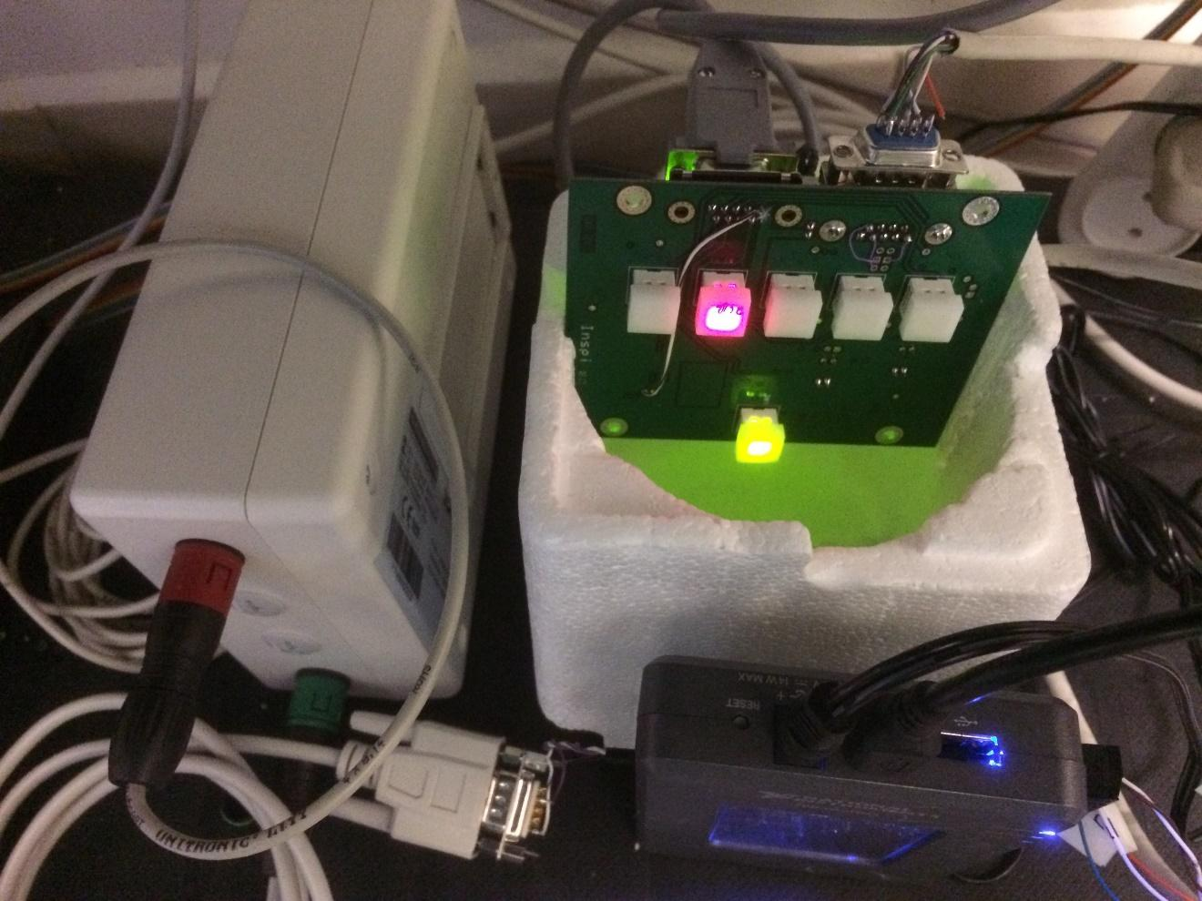

1. Insert your Dorset antenna to the behavioral chamber and reassemble the chamber. Use the following images as a reference:

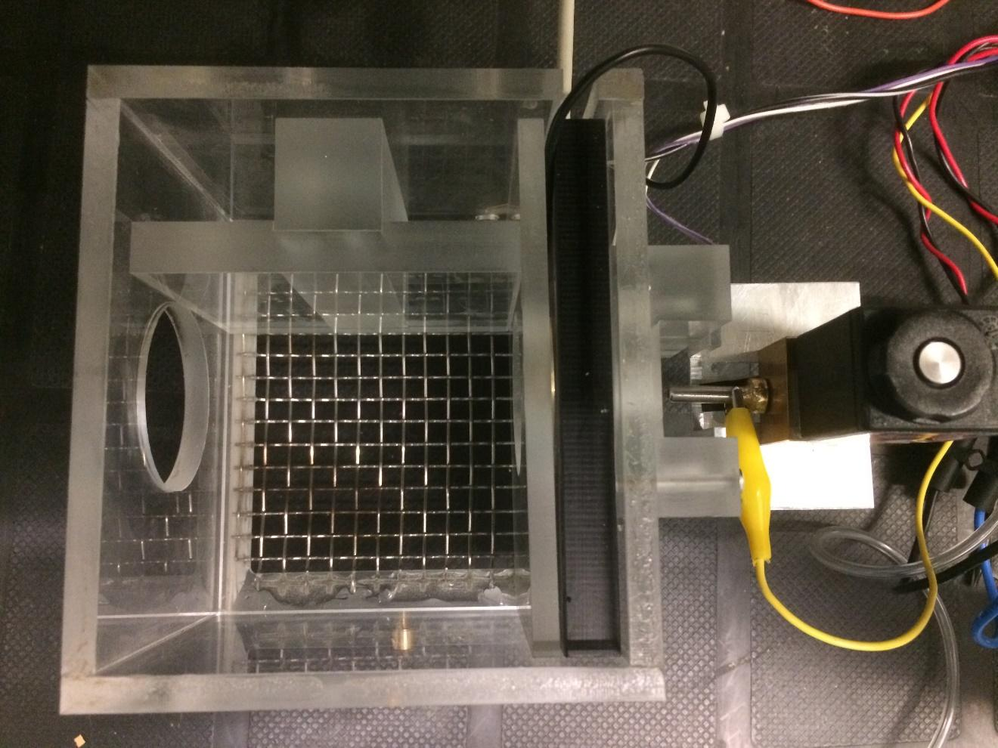

1. Connect the LICK1 connector to the water valve as in the top image.
2. Connect the valves to your water resource.
3. Connect RFID antenna to Dorset decoder (LID665) and the decoder to myRIO DIO (left side – panel A ; ports 10, 12) via serial cable. Use the following wiring map:  
   R_out-> 12  
    Ground->10

Instructions on how to disable the buzzer of the RFID decoder can be found on the last pages of this guide.





1. Plug in the electricity of the Doreset decoder, myRIO and the PCB and turn on the power of the PCB by long pressing on the on/off button.
2. The stimulus indexes are transmitted in binary via Connector B:  
    Ground -> 8 GND

Signal bits -> DIO0-DIO7

Control bit (Will always be on when there’s a transmission) -> DIO8  
 (For example, if the stimulus index is 5 then DIO3 and DIO0 will be on while the rest will be off (0000101b = 5)

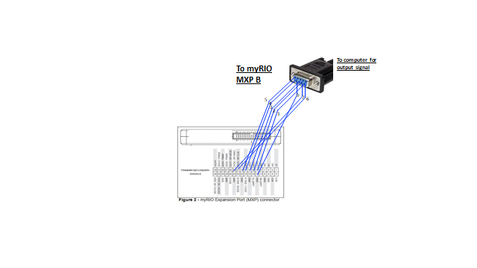

9. AUX connection can be used to play sounds generated by the internal synthesizer.

***Software installation***

1. -Install LabView on your working station and select the following options (it might take about an hour to complete):

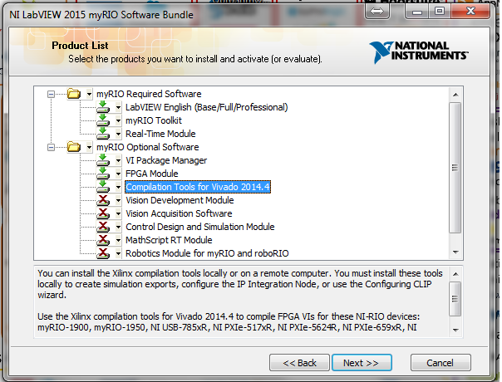  
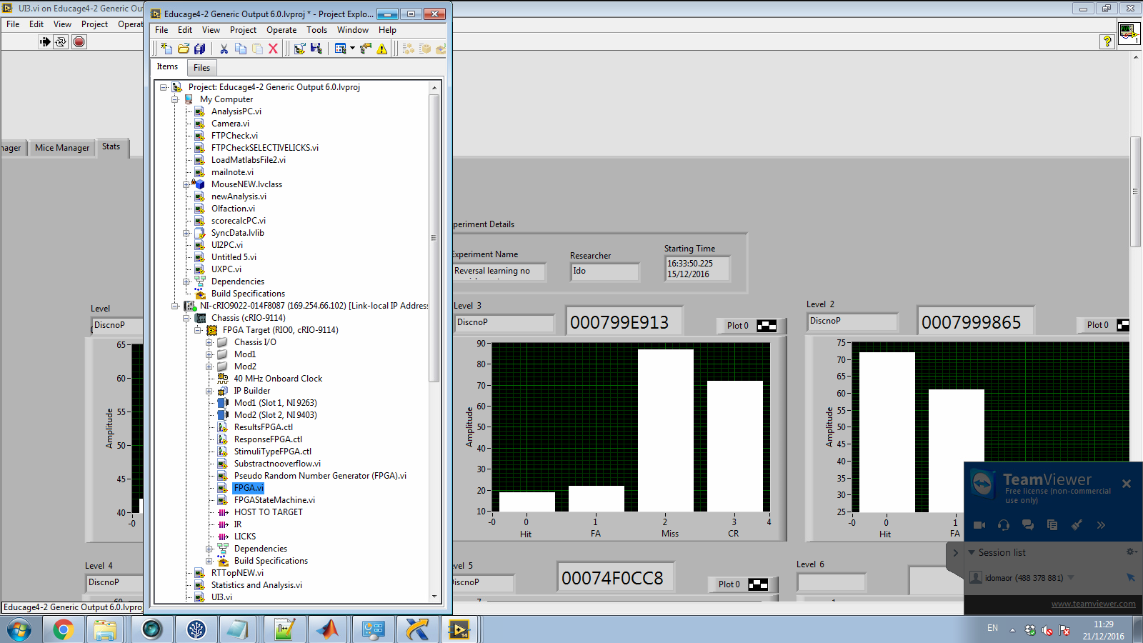

1. Open miniEducage project (after extracting the files).
2. Connect the myRIO via USB connection.
3. -Install legacy ftp server:  
   In NI MAX, under “Remote Systems” choose your device and right click on Software and click on Add/Remove software, choose next, in the current window find and tag “Legacy FTP Server” and install it (click next).  
     
   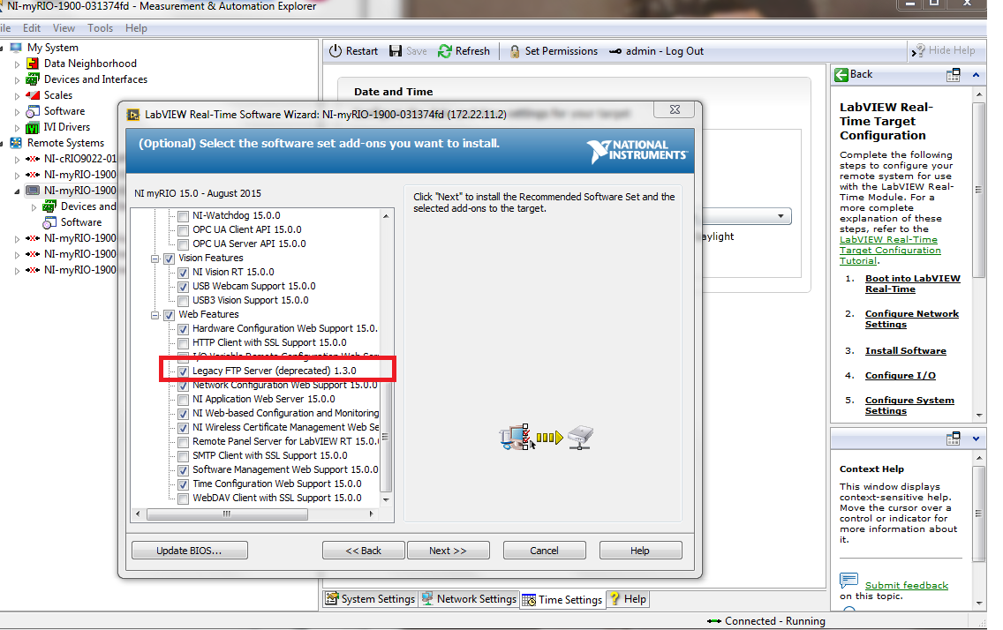
4. Open FPGA VI (see the path on the right)

and run it (press white arrow).



1. When running FPGA vi, you will be prompted to select compilation tool:  
   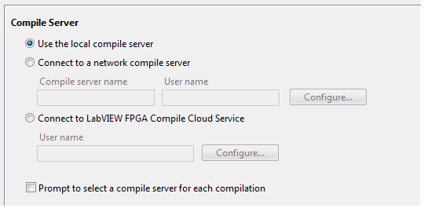

1. Open UI3 VI and run it.

Use this VI in order to operate the system, design experiments and tracking mice performances.



***Run a new experiment:***

**Register new mice**

1. Choose the check RFID tab.

2. Activate Read RFID

3. Read RFID using the antenna (better save the IDs in a registration file).

4. deactivate the Read RFID on completion.

**Design level sequence-**

1. Choose the Level Manager tab.
2. Activate level entry.
3. Load desired sequence (drag and drop sequence name from the list to the 'sequence name' window and press- **Load sequence**).
4. Modify level parameters and upload level (see the ‘design level sequence’ section)
5. Upload sequence to system

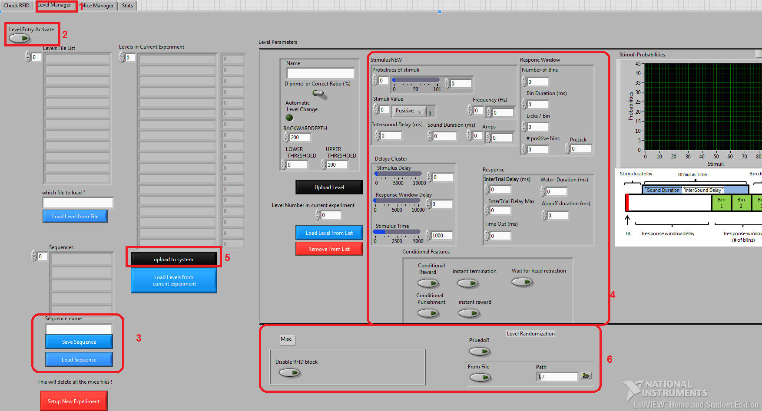

**Select experimental mice and run experiment**

1. Choose the Mice Manager tab.
2. Activate mica manager tab.
3. Upload experimental mice in the desired level- enter the name of the mice, choose level number and press 'upload mouse parameters'.

(To read RFID chips use the Check RFID tab).

1. Register experiment details
2. Run experiment

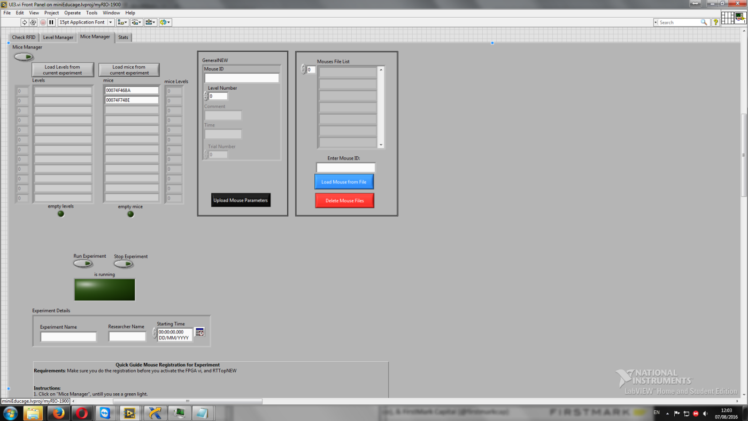

**Design level sequence**

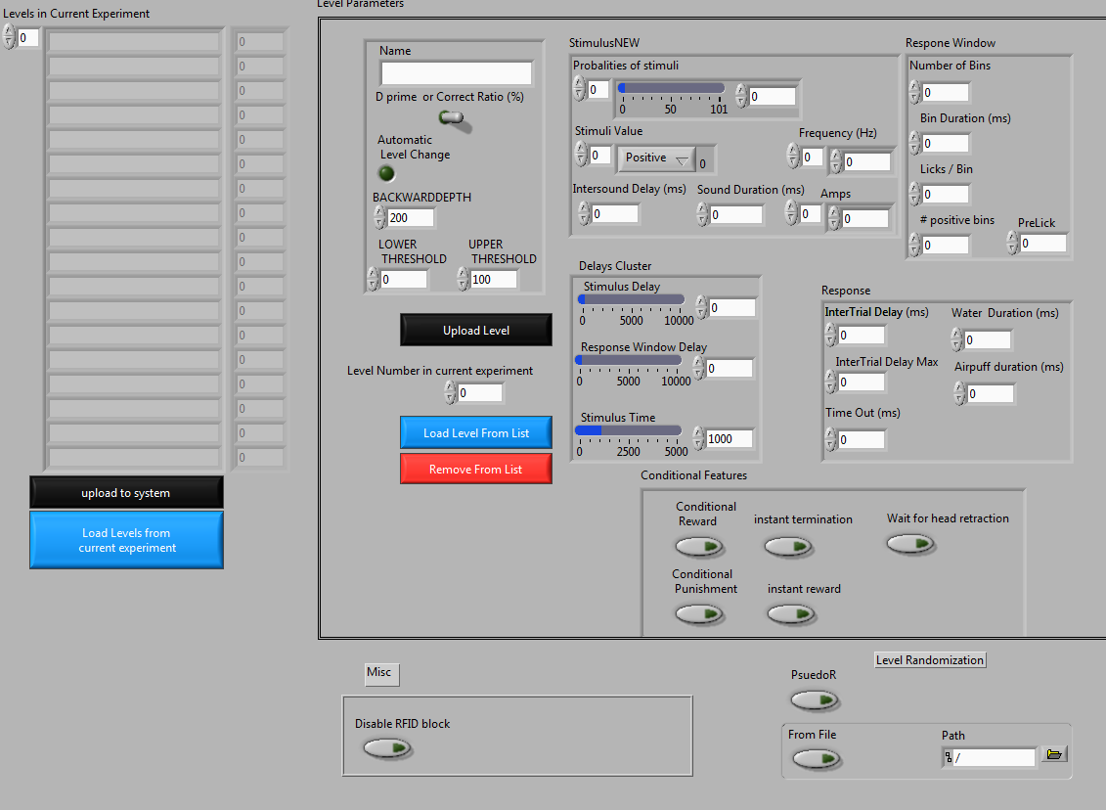

**Name-** the name of the level, as it will be saved.

**Automatic level change-** if enabled, levels will be transferred according to mice performances:

**d'/Correct ratio toggle-** define score mode

**Backward depth-** number of last trials from which score will be calculated**.**

**Lower threshold-** if score reach this threshold, level will be decrease.

**Upper threshold-** if score reach this threshold, level will be increase.

**Level number in current experiment-** the chronological order of the level sequence. Starting form 0 up to…

**Probabilities of stimuli-** each trial the system generates a number between 100. This number will then be mapped to a specific stimulus according to the delta of the assigned probabilities. For example, if we defined the following stimuli probabilities:  
1 – 10

5 – 50

9 -101 (setting probability to max will automatically assign it the (100 - Rest of stimuli- probabilities)

(and the rest of the stimuli are 0 )

1- Will occur 0.1 of the time.

5- Will occur 0.4 of the time

9 – Will occur 0.5 of the time.

Make sure the last stimulus will get the value of 101 so all possible generated numbers are mapped to specific stimuli.

The defined probabilities are represented as bar graph on the right figure.

**Stimuli value-** the valence of each stimulus: positive (‘go’ response will be rewarded) /negative (‘go’ response will be punished) /no effect (neutral stimuli without an outcome)**.**

**Frequency-** Frequency of the tone that will be generated at the period of **Stimulus Time**,  
each frequency corresponds with a specific stimuli index.

**Amps-** Determines the volume of the tones, corresponds with specific stimuli index

**Sound Duration-** Determines for how long the tone will run continuously in each cycle.

**InterSound Delay-** Determines for how long the tone will pause before restarting.

**Stimulus delay-** time from IR breaking (trial initiation) to stimulus onset.

**Response window delay-** time from IR breaking to response window onset.

**Stimulus time-** duration of stimuli (TTL output).

Response window parameters:

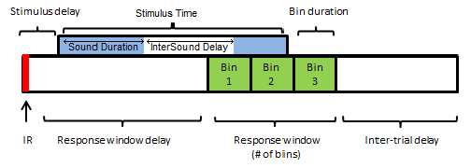

Define 'go' response:

**Licks/Bin-** licks threshold for positive bin.

**# of positive bins-** positive bins threshold.

Conditional features:

**Conditional reward-** reward will be given only if mouse blokes IR at the end of the response window.

**Conditional punishment-** air puff will be given only if mouse blokes IR at the end of the response window.

**Instant termination-** trial will terminated as soon as mouse stopped blocking IR.

**Instant reward-** trial will terminated and reward will be given as soon as mouse reached threshold for 'go' response.

**Wait for head retraction-** When activated a new trial will not begin until the mouse retracts its head.

Misc & Level Randomization

**Disable RFID block-** When ‘On’ the trial will begin even when the RFID of the mice was not fully read/recognized by the system, in these cases the data will be written on the last recognized RFID that was activated.

**PsuedoR-** When activated it will prevent cases of 4-way-repeated stimuli indexes.

**From File-** When activated, with a chosen **Path**, the stimuli will be ran from a file, note that this will override the **Probabilities of stimuli**

**Download mice files and analyze**



1. Open and activate the analysisPC program

2. Choose your saving folder

3. Click on ‘Load files from Real-Time’ and the green light to go off.

4. To plot learning curves: choose desired bin size and click on ‘Compute analysis’.

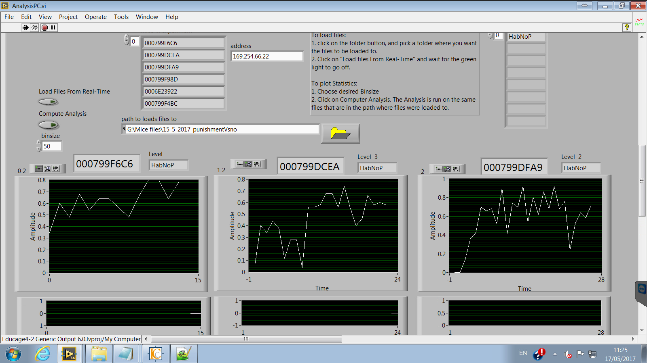

**Disable RFID buzzer:**

Download and install LID650-665 PC software:  
https://www.dorset.nu/en/home-id-2/support/lid665_650_1260_support/  
Connect Dorset decoder via serial cable to computer port  
 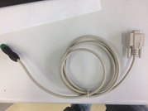  
Start the software. When the program is executed, the comport has to be selected where the program should search for the connected decoder(s).  
 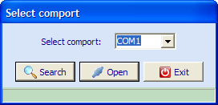  
Uncheck the Use buzzer box:  
 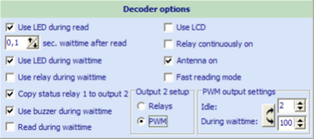  
Choose set new settings:  
 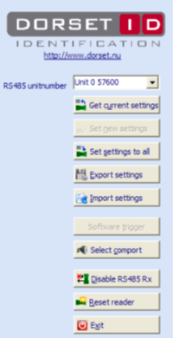

**Data analysis**

Data for each mouse is stored on the myRIO in 3 separate doc files, named by its RFID string.

The first is a file with the .mosix extension.

The second is a file with Lck extension.

The third is with the IR extension.

All files can be accessed via NI MAX (NI measurements and automation explorer)

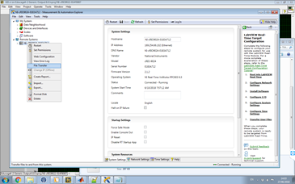

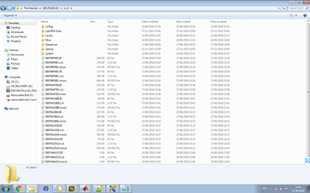

Or by downloading the files using the AnalysisPC vi.

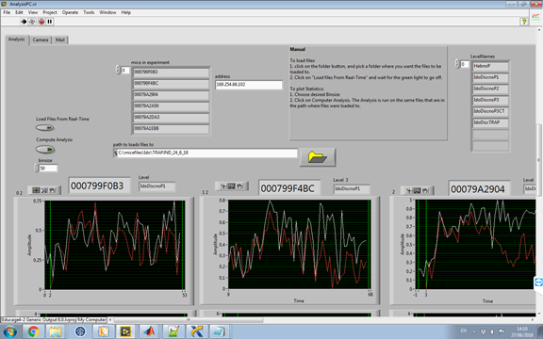

This vi loading the files of all the experimental mice to a specified folder, by pressing the ‘Load files from real-time’ button. Rough analysis of Hit (white curve) and false-alarm (red curve) rates can be performed by pressing the ‘Compute analysis’ button (after choosing a specific trial bin size).

In those log files, each line corresponding to one trial

Mosix file:

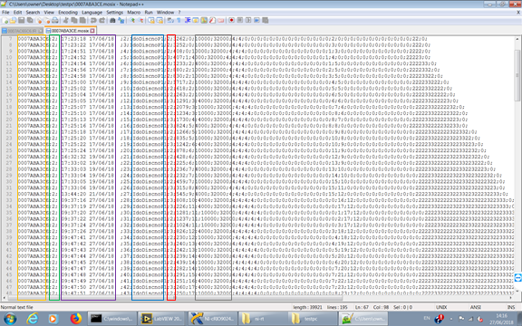

Name of the mouse (RFID)

Level index

Time and date of beginning of trial.

Name of level

Trial score:

0=Hit

1=False alarm

2=Miss

3=Correct rejection

Played stimulus (frequency and amplitude).

Lck file- information on licks events in each trial. Positive and negative values corresponding to time in ms of touch and release of tongue respectively.

IR file- information on head retraction.